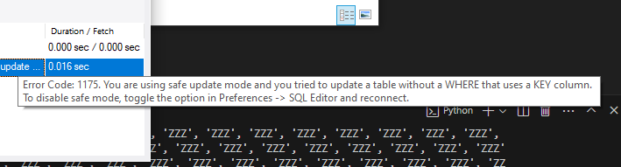

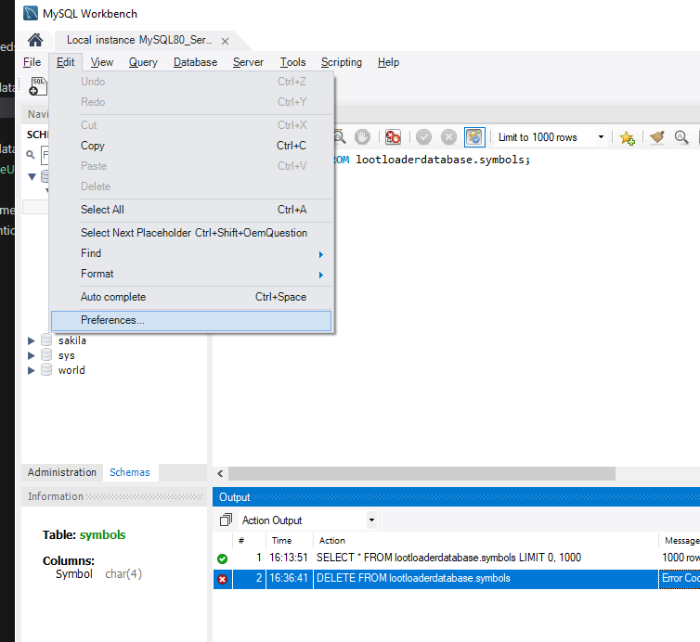

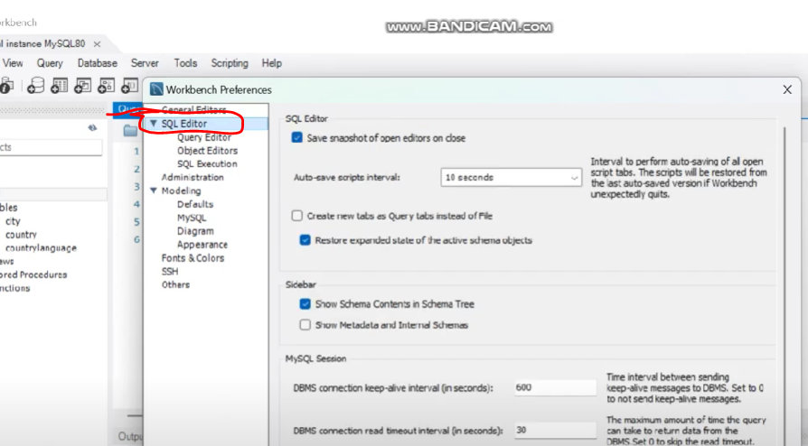
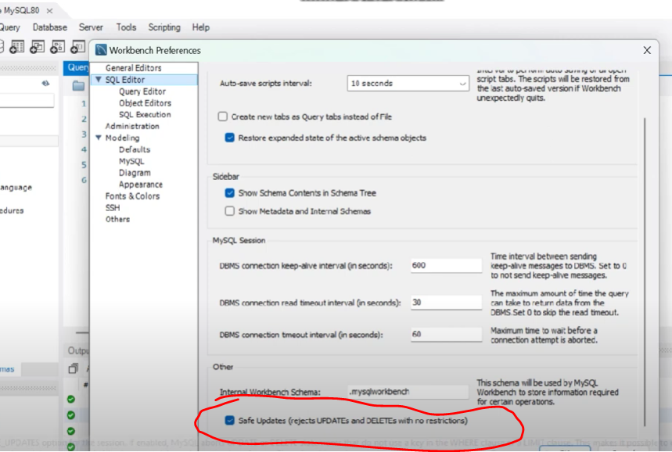

Finally – you have to restart MYSQL Workbench
https://www.youtube.com/watch?v=qhwYOgZfqCg&ab_channel=TecnoTab

